Project Design Phase-II
Data Flow Diagram & User Stories

Date | 14 July 2026
Team ID
Project Name | InterviewAI – Intelligent Hiring & Candidate Evaluation System
Maximum Marks | 4 Marks
Name | Tirumani Sai Manikanta

Data Flow Diagrams:
A Data Flow Diagram (DFD) is a traditional visual representation of the information flows within a system. A neat and clear DFD can depict the right amount of the system requirement graphically. It shows how data enters and leaves the system, what changes the information, and where data is stored.
Example: DFD Level 0 (Industry Standard)
Example: (Simplified)
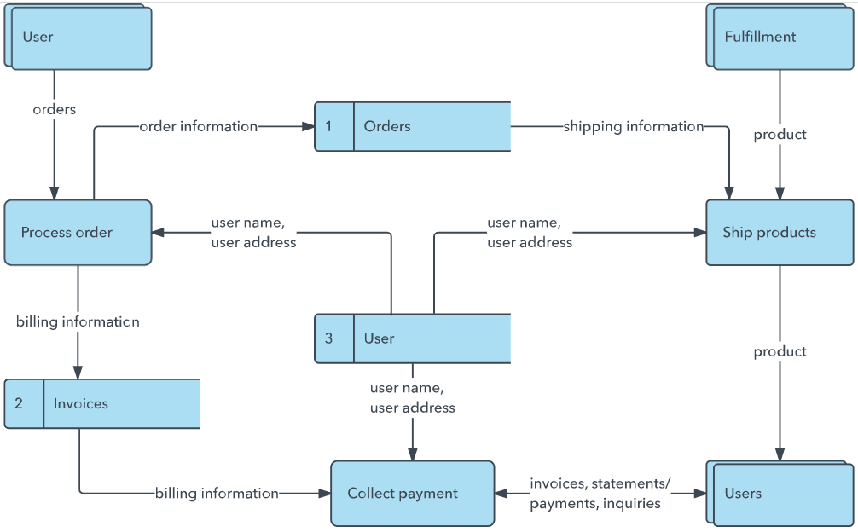


User Stories
Use the below template to list all the user stories for the product.
User Type | Functional Requirement (Epic) | User Story Number | User Story / Task | Acceptance criteria | Priority | Release
Recruiter | Question Generation | USN-1 | As a recruiter, I can enter a job role, experience level, and interview type so InterviewAI generates a tailored question set. | I receive the requested number of questions, each with a follow-up, evaluation tip, green/red flags, and a scoring guide. | High | Sprint-1
 |  | USN-2 | As a recruiter, I can add optional notes about my team/org so generated questions reflect that context. | Generated questions visibly incorporate the notes I provided. | Medium | Sprint-1
 |  | USN-3 | As a recruiter, the app validates the experience level and interview type against the allowed set before calling Gemini. | Invalid values return a 400 error instead of an API call. | Medium | Sprint-1
 | Session Ledger | USN-4 | As a recruiter, my generated session is saved automatically to a Session Ledger. | The new session appears at the top of the ledger immediately after generation. | High | Sprint-1
 |  | USN-5 | As a recruiter, I can reopen a past session from the ledger. | Reopening a session loads it instantly without another Gemini API call. | Medium | Sprint-2
 |  | USN-6 | As a recruiter, I can delete an old session I no longer need. | The deleted session disappears from the ledger and from disk. | Low | Sprint-2
 |  | USN-7 | As a recruiter, each ledger entry shows the role, level, type, and question count before I open it. | I can identify the right past session without opening it. | Low | Sprint-2
Recruiter | Word Export | USN-8 | As a recruiter, I can export any saved session to a formatted Word (.docx) document. | The downloaded file opens with color-coded green/red flags and the scoring guide. | High | Sprint-3
 |  | USN-9 | As a recruiter, I can re-run generation with the same role/level/type without retyping everything. | A repeat-generation option reuses the previous inputs. | Low | Sprint-4
Administrator | System Health | USN-10 | As an administrator, I can call /api/health to confirm the Gemini API key is configured before recruiters start using the tool. | The endpoint returns gemini_key_configured: true/false. | Low | Sprint-3
 |  | USN-11 | As an administrator, exported .docx files are kept under exports/ for later reference. | Each export creates a uniquely named, timestamped file on disk. | Low | Sprint-4
 |  | USN-12 | As an administrator, I see a clear error code (missing_api_key / generation_failed) when Gemini calls fail. | API error responses include a machine-readable code and a human-readable message. | Medium | Sprint-1

